Exam Solution

Kostadin Kostadinov

After running the vagrant file with **vagrant up**

I am connecting to the ansible host and executing the playbooks with the following commands:

**vagrant ssh ansible**

**cd /playbooks**

**ansible-playbook install-both.yml**

After they are completed the nrpe plugin on the docker host should be working:

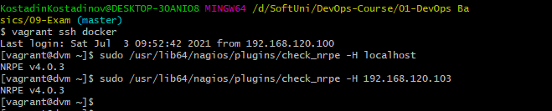

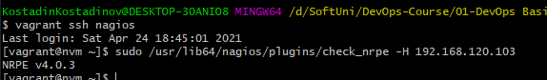

T303 - I add global credentials in Jenkins for the vagrant user with password vagrant:

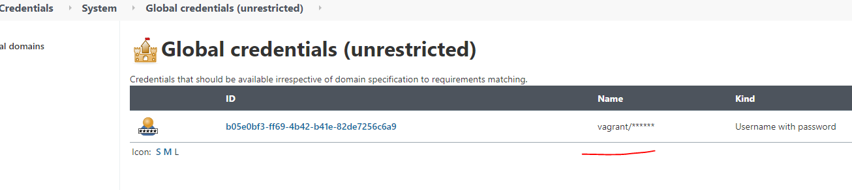

T304 - Added a docker agent to Jenkins:

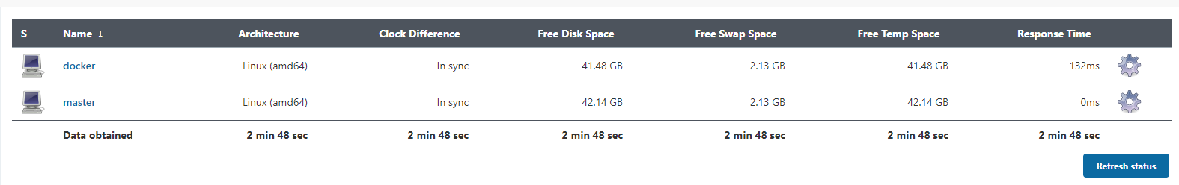

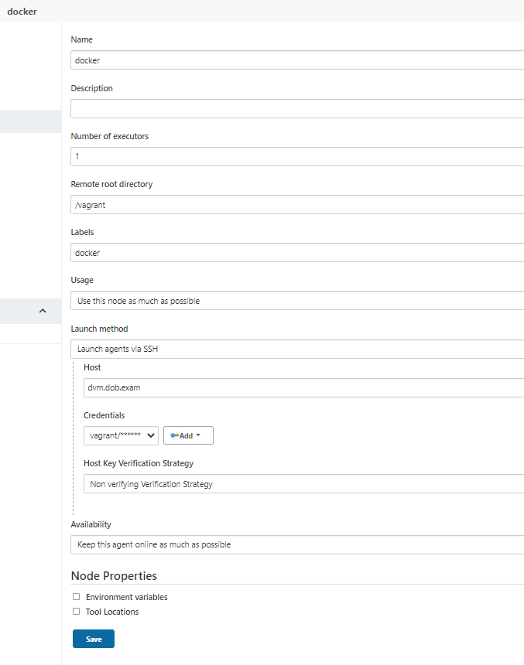

T305, T306 – Create a project:

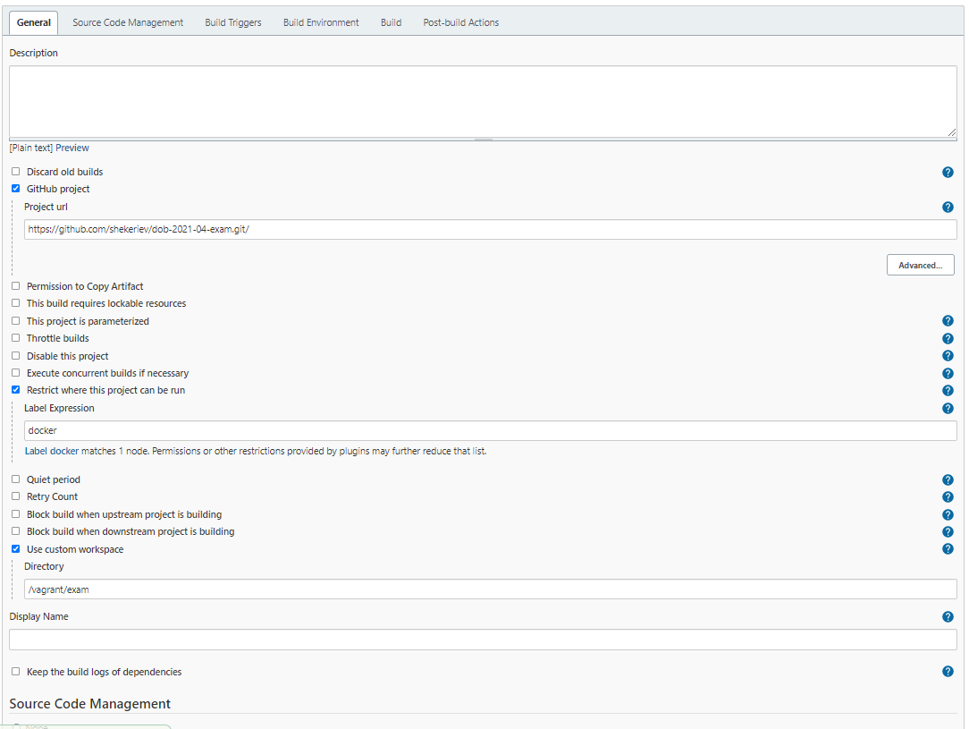

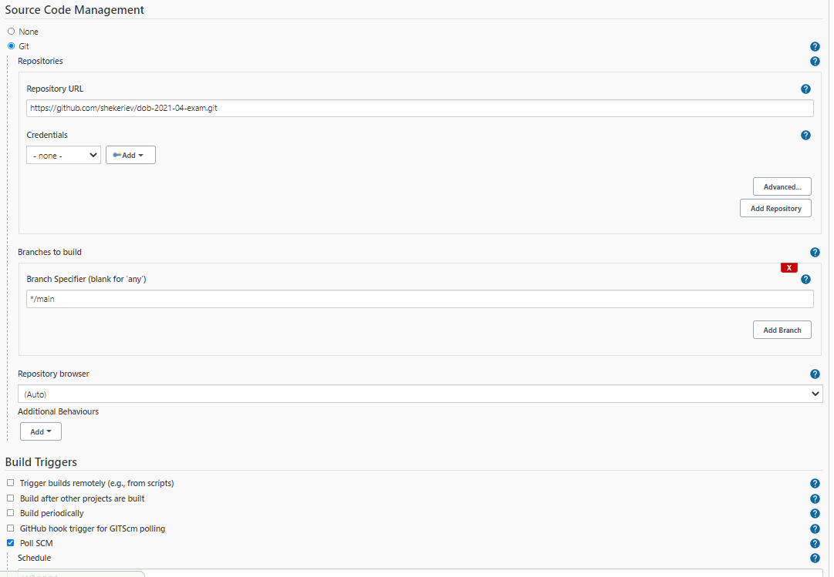

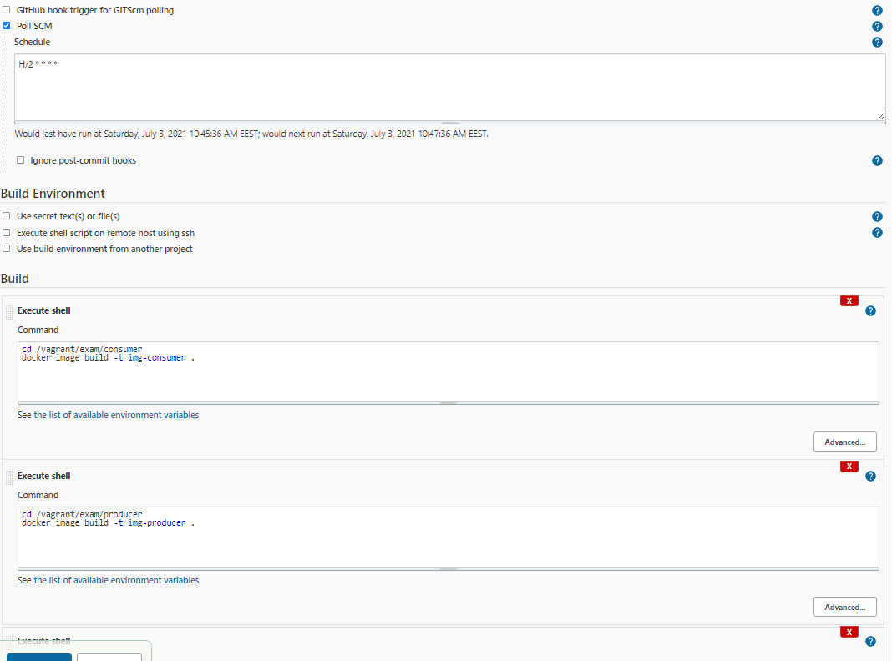

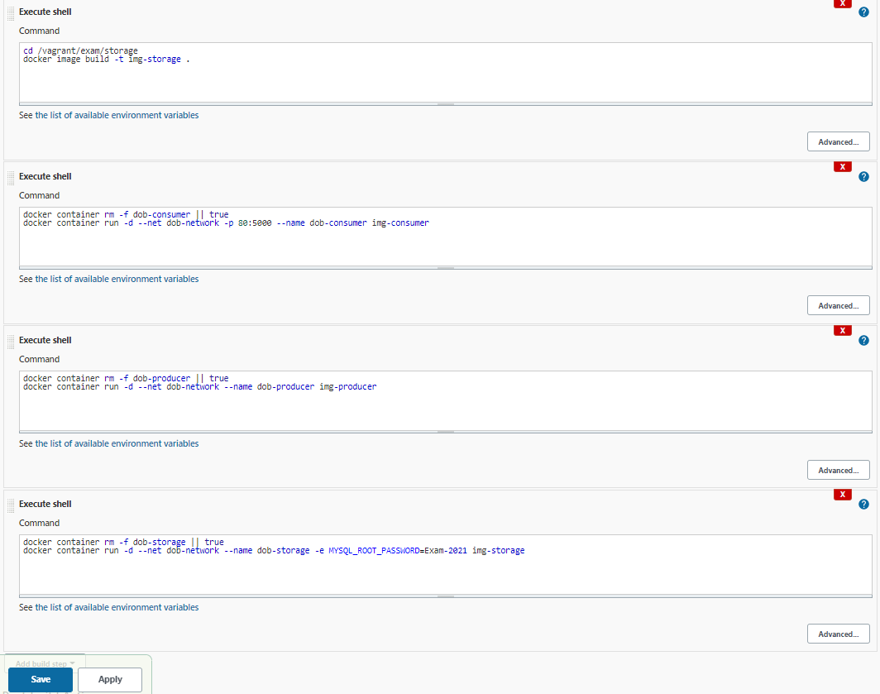

After the project is saved and has finished executing the web app should be available at http://localhost:8002/

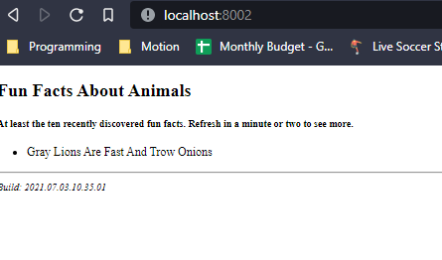

Nagios

